Strategic Leadership Development Design Mini-Workbook

1. Goals: Add any missing strategic goals to this list and then select just ONE goal that is a high priority goal for your organization at this time. (↑ = increase or improvement) In the full workbook we encourage you to select several, but time is tight here.
↑ Leadership Bench Strength | ↑ Employee Motivation | ↑ Productivity (Revenue / employee) | ↑ Customer Satisfaction
↑ Profitability (bottom line) | ↑ Gross Revenue / Sales | ↓ Waste / Scrap | ↑ Revenue / customer
↑ Customer loyalty | ↑ Quality or Consistency | ↑ Employee retention | ↑ New Customer acquisition
↑ Speed in bringing products to market | ↑ % Market share | ↑ Timeliness in delivery | ↑ Operational Efficiency
Others ⇒ | _________________ | _________________ | _________________

2. Return on Investment: If you can achieve that goal you have identified above, what benefits (both tangible and intangible are likely to accrue?
Goal | What is likely to happen when you achieve that goal? | Guess that benefit in $ over 3 years

3. Competency: Add any vital missing competencies to this list and then select ONE you most need in Leadership in your organization to achieve the goal you selected in step 1. In the full workbook, we encourage you to select 10-12 competencies - consider this a taste test.
(note: Competencies run for 2 pages)
Communication Competency: | Influencing and Persuading others | Creating memorable and impactful messages | Enrolling followers with vivid stories
Presenting to others | Constructive Use of Humor | Listening to understand | _________________
Developing and Motivating Competency: | Understanding the capabilities of others | Evaluating and supporting improvement | Coaching and mentoring
Constructive feedback and counseling | Effective teaching | Treating people fairly | Managing conflict
Empathy | Interviewing and hiring skills | _________________ | _________________
Delegating to inspire performance Competency: | Building shared understanding and goal clarity | Using the resources of the team or group | Managing appropriately for the situation
Sharing leadership | Representing the group | Holding people accountable for results | _________________
Strategic thinking Competency: | Thinking of the whole and how best to support that | Ability to see patterns and trends | Problem-solving
Taking initiative | Critical thinking | Decision-making | _________________
Leading innovation Competency: | Creating an environment of innovation/ creativity | Using decision-making approaches that maximize innovation | _________________
Managing change Competency: | Advocating for change | Leading organizational change | _________________
Facilitation of group process Competency: | Building shared understanding and goal clarity | Making time for your team | Building and sustaining high performing teams
Working with others who may be smarter than you are | Collaborating with people in other departments | _________________ | _________________
Self Awareness and Continuous learning Competency: | Learning from others | Knowing what you need to learn | _________________
Other Competency areas: | _________________ | _________________ | _________________

4. Methods: How well developed do you need that competency to be? Ask these questions about that competency. Do you need people just to understand the idea? Or do you need them to develop an ability to use it occasionally? Or to be able to use it without having to think about it? Is mastery required? Different learning methods lead to different levels of acquisition of competence.

5. For the Competency you identified in the previous step, identify the level of mastery that you think your leadership has, and the level it needs in order to meet your goals. Circle the ideal methods of achieving that level of mastery.
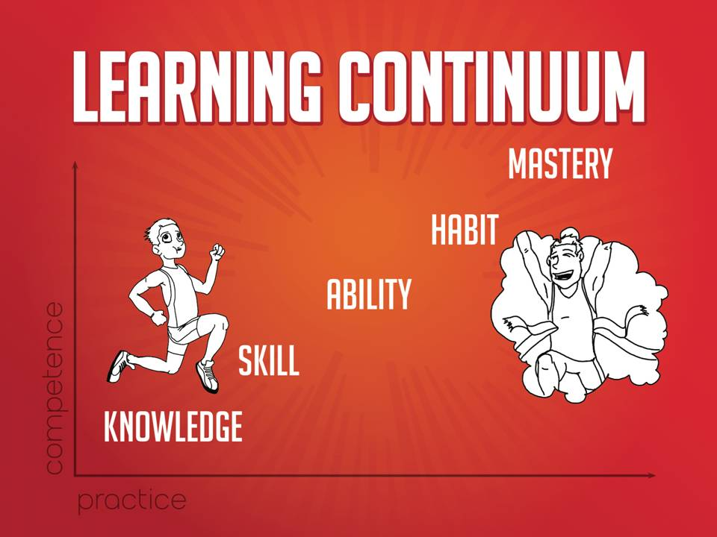

Competency | What level of competency does leadership have need | Ideal methods for achieving that level of mastery
 | knowledge  skill  ability  habit  mastery | lecture - listening to a professional  reading  discussing  practicing - simulated problems  teaching - to others  applying - real world issues

This document is merely a mini-workbook. We also have a more detailed workbook and are working on developing an online tool to help you run this process with other leaders in your organization. The detailed workbook has multiple goals, ROI for each, multiple competencies, etc. If we have your business card, we will email you to tell you when this document is available on the web, and when our online tool is available as well.
In our experience, a well-designed leadership development program will almost always pay for itself immediately. Homework projects between sessions usually result in significant savings to the organization, more than offsetting the cost of the program.

Please call if you have questions, comments, suggestions for improvement, etc.

Bob Faw
Chief Energizing Officer
Matchbox Group
bob@matchboxgroup.com
(603) 882-2109

