- What are your top 2-3 goals for today? How will you do in order to achieve those goals?

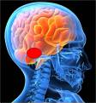 | Brain Science: The amygdala, part of our limbic systems, is primarily focused on survival. It gives us energy to protect ourselves by pumping adrenaline and cortisol into our bodies for energy and decreased pain sensitivity. It is responsible for survival, eating and mating. It cannot tell the difference between a life and death threat and an emotional one. So it often reacts as if there is far more danger than there is. ³²
 | Caveman’s Passion: We nicknamed the amygdala the “Caveman” because of its high emotion and lack of thought when activated. However, we can tap into the passion that the Caveman brings to everything to fuel major change. Lasting change requires the energy and optimism that the Caveman provides when excited about the results and the process. ³²
- Where can you ignite people’s passion to avoid conflict, or to redirect people once it starts?

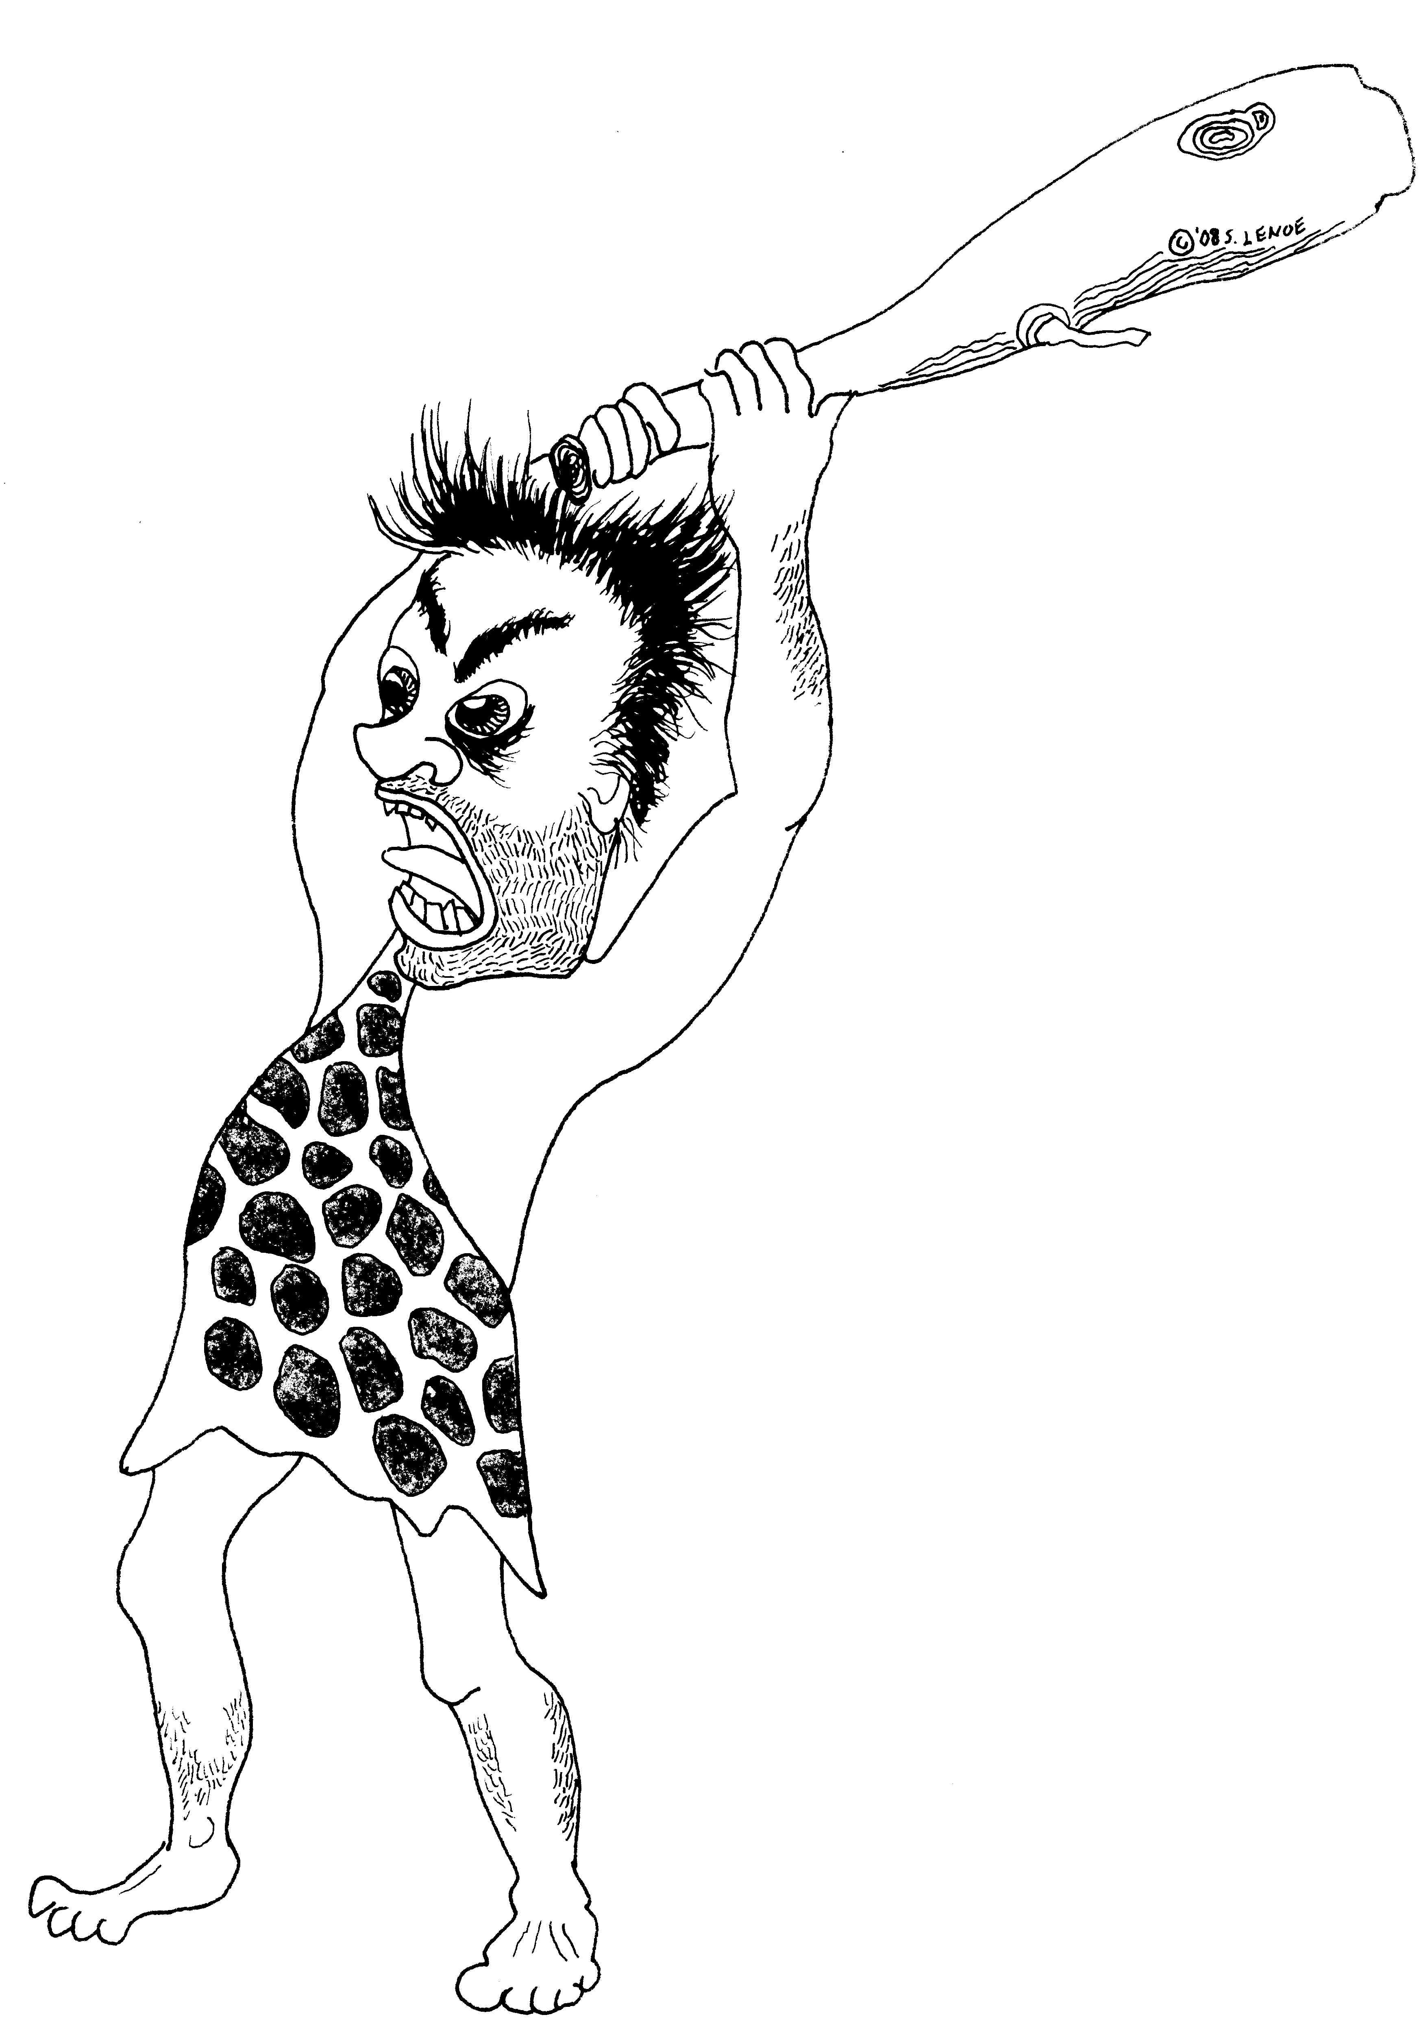 | Caveman’s F Responses: We also nicknamed the amygdala the “Caveman” because it is the most primitive part of our brain. It is responsible for our survival. It triggers the Fight, Flight and Freeze responses. These rush through our bodies in milliseconds, before our conscious mind can make meaning of the situation. These can cause a decrease in working memory²⁸ that can last 18 minutes. Our ability to see multiple options drops from 16 to 9 to 3 to 1; and that one response will be fight, flight or freeze. This dynamic can literally disconnect neural connections in the “Thinker” (prefrontal cortex), lessening the ability to control impulses^{31,32}.
- Where do we see F-responses at work? What does it look like? What behaviors do we actually see?

- Where do we see F-responses at home? What does it look like? What behaviors do we actually see?

- Where do we see F-responses in ourselves? What does it feel like? What behaviors do we actually do?

- What are some of the things that trigger these F-Responses?

- With your partner, discuss one thing that you have said in the past that created conflict. Write that on a card too.

- What situations, relationships, topics trigger your own F-Responses?

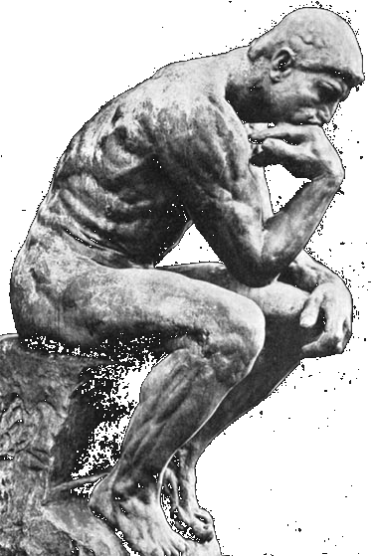 | Thinker: We nicknamed the prefrontal cortex the “Thinker” because of its ability to plan, think complex thoughts, consider consequences of actions, and to moderate correct social behavior. The Thinker in each of us helps us to see the big picture, to come up with creative responses to challenges, and to see others’ points of views. ³²  However, logic without emotion actually diminishes leadership, teamwork and motivation.  By balancing the passion of the Caveman with the forethought of the Thinker we can act powerfully and wisely. We can choose language (e.g., reframes) that motivates others.
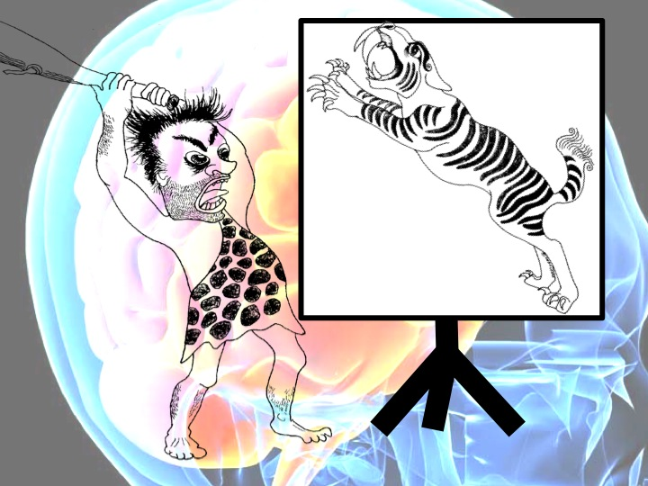  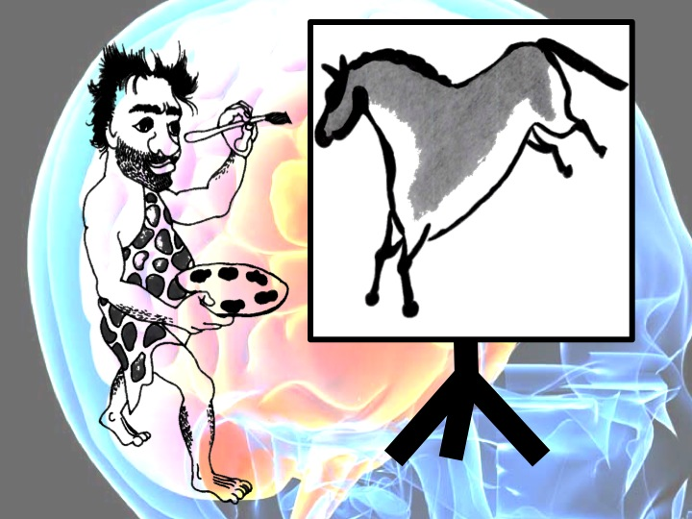   | Inner Movie: Our body follows the image on our “inner movie”. Highly successful athletes often visualize successfully accomplishing each step before attempting it. Jack Nicklaus wrote, “What we tell ourselves causes the whole body to respond to what the mind imagines is possible.”²⁴  Words create mental images and feeling states. Negative words such as “stop”, “avoid” and “don’t” try to negate them. The brain immediately sends out emotion biochemicals in response to imagery – creating feeling states within milliseconds. Plus, the brain does not know how to negate a mental image.  E.g., when we say to a child, "No, do not go into the swimming pool," the child’s mental image is going into the swimming pool. Therefore, saying not to do something urges our body to do the very thing we want to avoid. Instead say what you do want done.
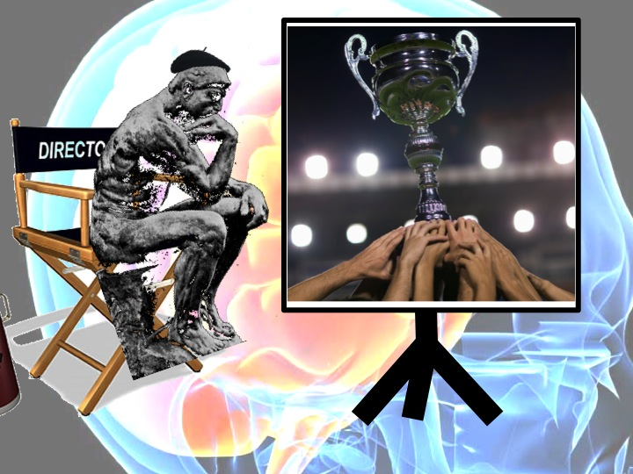 | Thinker as Director: Choose your words and tone carefully to help inspire the reaction that is most helpful. As JFK did in his 1963 “Man on the Moon” speech, create a movie in your follower’s minds that helps them see that they are a positive part of the solution you need. Ignite their caveman’s passion for the journey ahead and their parts in it.
- How do already you influence your own inner movie to prevent more conflicts?

- How else you influence your own inner movie to prevent more conflicts?

- How can you influence other peoples’ inner movies to prevent conflict?

 | Venting: Venting is a natural reaction to an F Response. If done well it can help diffuse an F Response. If done poorly it aggravates the F Response; for oneself, the listener, and the subject of the venting. Our guideline: Any way of expressing emotion is helpful–as long as no one gets hurt.  - Suggestion: Ask your close friends, “Can I vent? Don’t take what I’m about to say as my actual opinion. I just need to blow off steam.”  - Talk about your emotions and perceptions rather than name calling and blaming.
 | Calm the Caveman: Our parasympathetic nervous system sends out biochemicals that help us relax, recharge and refocus. They help us think more calmly and clearly²⁹.  When we balance the energy of the Caveman and the calm of the Thinker we can achieve a solution-focus. Plus, a solution-focus helps us to find this balance. It works both ways. This is one of the many wonders of how our bodies work.  Some ways of calming the caveman are: slow, deep breathing; positive imagery; taking a break from a situation; stretching, emotionally enriching experiences; thinking about the positive traits/accomplishments of the person you’re upset with; soothing music… and a solution-focus.

- What are your most effective ways of calming your own caveman?

- What else would you like to try to help calm your caveman?

- What are your most effective ways of calming other’s cavemen?

 | The Power of Focus: The human brain can only take in so much data at once.  What we unconsciously or purposely focus on ends up limiting our ability to see other things³⁰. So what happens when we choose to look mostly at negatives or limitations? What happens when we focus mostly on success? Choosing to focus on solutions enables us to see opportunities that we may have otherwise missed³².
 | Thinker’s Positive Change Questions^{33&34}: Create positive direction, momentum and creativity–fast. Goals? This question can focus us on long-term objectives or the next action we need to do. It gets us back on track. What works? This helps us build upon momentum by first asking about our past successes³² and current strengths; then broadens our focus by learning from others’ best practices. What else? This gets us brainstorming new ideas, adapting past practices and innovating. This is a more positive way to create solutions for a “gap” – with creating defensiveness for those who we think created the gap. This is also where we focus on our next steps–keep moving.

- Where can you use the Thinker’s Positive Change Questions to avoid, reduce, or manage conflict?

- In your department, what are the goals?

What works?

What else could you be doing?

 | Bowling Study: In one study researchers used video to record a bowling match. For the one team, they edited out everything done right and used the traditional training method of showing the team its mistakes and strategizing how to correct them. For the second team, the experimenters edited out all of the mistakes and showed the team the film of everything they had done right. While both teams improved, the team seeing what they did right had 100% greater improvement than did the team that was shown its mistakes.⁴
 | 10:1 - Ideal Positive:Negative Balance: Using a “Capture Lab” researchers²² saw a strong average correlation between positive language and performance. Low performing teams communicated 1 positive for every 3 negatives – 1:3; Medium teams averaged 2:1; High performing teams ranged from 6:1 to 11:1. Too much positive, 12:1 or more, “calcifies a team”, making necessary change and adaptation difficult.  Sustainable marriages¹⁸ apparently need at least 5 times as many positive emotions regarding one’s partner as negative–5:1.
NEG. | Problem focus often does work. It is a legitimate and natural approach. Drawbacks: It usually takes a longer to get to the solution. It creates more resistance along the way. Advantages: It is more intuitive, particularly under pressure. There are times where a brief time focusing on the problem is necessary before moving to solution focus; specifically venting, acknowledgment, empathy and/or apologies. These may be helpful at times to rebuild trust and get back to a solution-focus. At times analyzing past problems may yield useful data.
- What are specific areas, where you have influence, where you would like to see 10:1 positive to negative comments?

 | Chameleon Effect³⁶ on ourselves: We all have an "inner movie" going continuously in our minds, projecting ahead of ourselves both optimistic and fearful images. Scientific research is full of examples of our beliefs and internal images heavily influencing our capabilities³². The Chameleon Effect (Placebo Effect) even helps people recover from many illnesses. Research on patients recovering from heart surgery has shown that; those who fared the most poorly had a 1:1 ratio or worse of good to bad images; those that recovered the best had a 2:1 ratio of good to bad images.
 | Chameleon Effect³⁶ on Others: Teachers in one experiment were told that certain children were gifted, and certain children had difficulty learning. In truth all the children were randomly selected. The teachers unconsciously began to treat these two groups differently. Even more remarkable was how the teachers’ actions affected the children. The “gifted” children's performance improved and the “difficult” students’ performance deteriorated. The effects, positive and negative, lasted for years.²⁵ ²⁶ In a 2007 article one student admits that he is still negatively impacted by that experiment decades later. An example of a positive Chameleon effect is: One poll of fortune 500 senior executives revealed that every one had a mentor that believed in them when they first started managing.
 | Chameleon Principle: We form certain expectations of people or events. We communicate those expectations with various cues (such as: words we use, tone of voice, volume, facial expressions, body language and amount of attention to them and about what). People tend to respond to these cues by adjusting their behavior to match them. This is especially true for those who depend on us. They even adjust their self-concept!

- How can you use the Chameleon Effect to create an even more positive inner movie for yourself? (write a specific example)

- How can you use the Chameleon Effect to create an even more positive inner movie for someone else? (write a specific example)

 | Reframing: Reframing our language helps us to influence the mental images that we and others see. This can make a huge difference in how others perceive us and what we’re telling them. This is also true with family and friends. This truly can help “Make Friends and Influence People”. Because of our caveman, our immediate gut reactions are often to focus on risks and only see problems. This can blurt out “caveman comments” that activate F Responses in others. Solution focused reframes creates movies in people’s minds of the goals and how to achieve them³². They also inspire the emotion needed to motivate people to action.
- What are 2-3 Reframes that you can use this week to help you influence people more positively with less conflict?

 | Power Reframes: This tool can create more motivation, guide positive action more powerfully and have a longer lasting affect than regular reframes. This is done by creating multiple positive images and feeling states. The first images influence every one after that. Thus the key is putting at least two benefits FIRST. This helps to create a positive inner movie and passionate cavemen before talking about the actions-which could potentially create F Responses if said first. Power Reframes are particularly helpful in helping people who are very stuck in conflict.

- What are 2-3 Power Reframes that you can use this week to help you influence people more positively with less conflict?

- What was the most helpful thing you learned today?

`
References used in the Training

- Ben-Shahar, Tal David. Harvard Professor who teaches “Positive Psychology”
- Blanchard, Kenneth, Johnson, Spencer MD (1982) “The One Minute Manager”. Berkley Books, NY
- Blanchard, K., Fowler, S., Hawkins, L. (2005) “Self Leadership and the One Minute Manager”: Increasing Effectiveness Through Situational Self Leadership. HarperCollins Publishers
- Behncke, L. (2004) “Mental Skills Training For Sports”: A Brief Review. Athletic Insight. The Online Journal of Sports Psychology. Volume 6, Issue 1 - March, 2004http://www.athleticinsight.com/Vol6Iss1/MentalSkillsReview.htm
- Buckingham, Marcus, (2001) “Now, Discover Your Strengths”
- Cameron, K.S., and Caza, A. (2005) “Developing Strategies for Responsible Leadership,” In Jonathan P. Doh and Stephen Stumph (Eds.) Handbook on Responsible Leadership and Governance in Global Business. New York: Oxford University Press
- Cooperrider, D.L. and S. Srivastva (1987) “Appreciative Inquiry in Organizational Life.” Research in Organizational Change and Development, 1: 129-169
- Covey, Steven (1989) “The Seven Habits of Highly Effective People”. Fireside, NY, Simon and Shuster Inc
- Dijkshterhuis, Ap and Knippenberg, Ad van (1998) “The Relationship Between Perception and Behavior, or How to Win a Game of Trivial Pursuit”. Journal of Personality and Social Psychology. 74. no. 4 (1998) 865-877
- Drucker, Peter, (1966) “The Effective Executive”
- Eden, D. (1990) Pygmalion in Management: Productivity as a self-fulfilling prophecy (Lexington, MA: Lexington Books)
- Eden, D., Geller, D., Gewirtz, A., Gordon-Terner, et. al. R. (2000) “Implanting Pygmalion Leadership Style Through Workshop Training: Seven Field Experiments”, Leadership Quarterly, 11: 171-210
- Eden, D. (1984) “Self-fulfilling Prophecy as a Management Tool: Harnessing Pygmalion”, Academy of Management Review, 9: 64-73;
- Eden, D. (1990) “Pygmalion in Management: Productivity as a Self-fulfilling Prophecy” (Lexington, MA: Lexington Books);
- Eden, D. (1992)“Leadership and Expectations: Pygmalion effects and other self-fulfilling prophecies in organizations”, Leadership Quarterly, 3: 271-305
- Fredrickson, B. L., & Losada, M. (2005) “Positive Affect and the Complex Dynamics of Human Flourishing”. American Psychologist, 60 (7), 678-686.
- Gladwell, Malcolm (2005) “Blink: The Power of Thinking Without Thinking”. Boston: Little, Brown
- Gottman, John and Carrere, Sybil (1999) “Predicting Divorce Among Newlyweds from the First Three Minutes of a Marital Conflict Discussion”. Family Process 38, no. 3 (1999): 293-301
- Kirschenbaum, D. S., Ordman, A. M., Tomarken, A. J., & Holtzbauer, R. (1982) “Effects of Differential Self-monitoring and Level of Mastery on Sports Performance: Brain Power Bowling”. Cognitive Therapy and Research, 6 (3), 335-342
- Jackson, Paul Z & McKergow, Mark. “The Solutions Focus”
- Livingston, J. S. (1969) “Pygmalion in Management”, Harvard Business Review, 47(4), 81-89
- Losada, M. & E. D. Heaphy (2004) “The Role of Positivity and Connectivity in the Performance of Business Teams: A Nonlinear Dynamics Model.” American Behavioral Scientist, Feb 2004; vol. 47: pp. 740 - 765.
Losada’s Website: http://losada.socialpsychology.org/
Fredrick’s Website: http://www.unc.edu/peplab/barb_fredrickson_page.html
- McAndrew, Frank (2008) “Can Gossip Be Good?” Scientific American Mind. October/November 2008
- Nicklaus, Jack (2005) “Golf My Way”
- Rosenthal, R., & Jacobson, L. 1968. “Pygmalion in the Classroom”. New York: Holt, Rinehart & Winston.
- Rosenthal, Robert & Jacobson, Lenore “Pygmalion in the Classroom” (1992) Expanded edition. New York: Irvington
- Seligman, Martin, 1999 speech as President of American Psychological Association
- Skosnik, P. D., Chatterton, R. T., Jr., Swisher, T., & Park, S. (2000). Modulation of attentional inhibition by norepinephrine and cortisol after psychological stress. International Journal of Psychophysiology, 36, 59-68
- Soothing the Amygdala: http://lifeatthebar.wordpress.com/2007/05/11/anger-managing-the-amygdala-hijack
- Chabris, Christopher and Simons, Daniel. (2008) The Invisible Gorilla: And Other Ways Our Intuitions Deceive Us
- Arneston, Amy; Mazure, Carolyn; and Sinha, Rajita “This Is Your Brain in Meltdown” (2012) Scientific American
- Rock, David; Schwartz, Jeffrey, “Neuroscience of Leadership” article (2006 Strategy+Business) reprint number 06207
- Faw, Bob, “An Old Sea Dog Can Learn New Tricks.” (2008) Seasonings, Organizational Development Network online. http://matchboxgroup.com/inspiring-tools
- Faw, Bob, “Staying Positive in Negative Times.” (2009) New Hampshire Business Review. http://matchboxgroup.com/inspiring-tools
- Faw, Bob, “Improvisational Leadership: Greater Buy-in and Morale on the Fly”. (2011) white paper. http://matchboxgroup.com/inspiring-tools
- Rom Brafman and Ori Brafman, (2008) “Sway: The Irresistible Pull of Irrational Behavior”

Other Positive Change Resources:
- Daniel Goleman’s “Emotional Intelligence: Why It Can Matter More Than IQ”
- Martin Seligman’s “Learned Optimism” – from Positive Psychology
- Positive Deviance Method: positivedeviance.org
- Bob Faw’s Blog on creating positive change: bobfaw.wordpress.com

